Stored Procedures:

i)usp_getOrderDetails



Output:

ii)usp_getPersonDetailsByName:



Output:



iii)usp_getPersonDetailsByName:



Output:



Triggers: Orders_Before_Insert





Output:



Views:

**Personorderitems:**

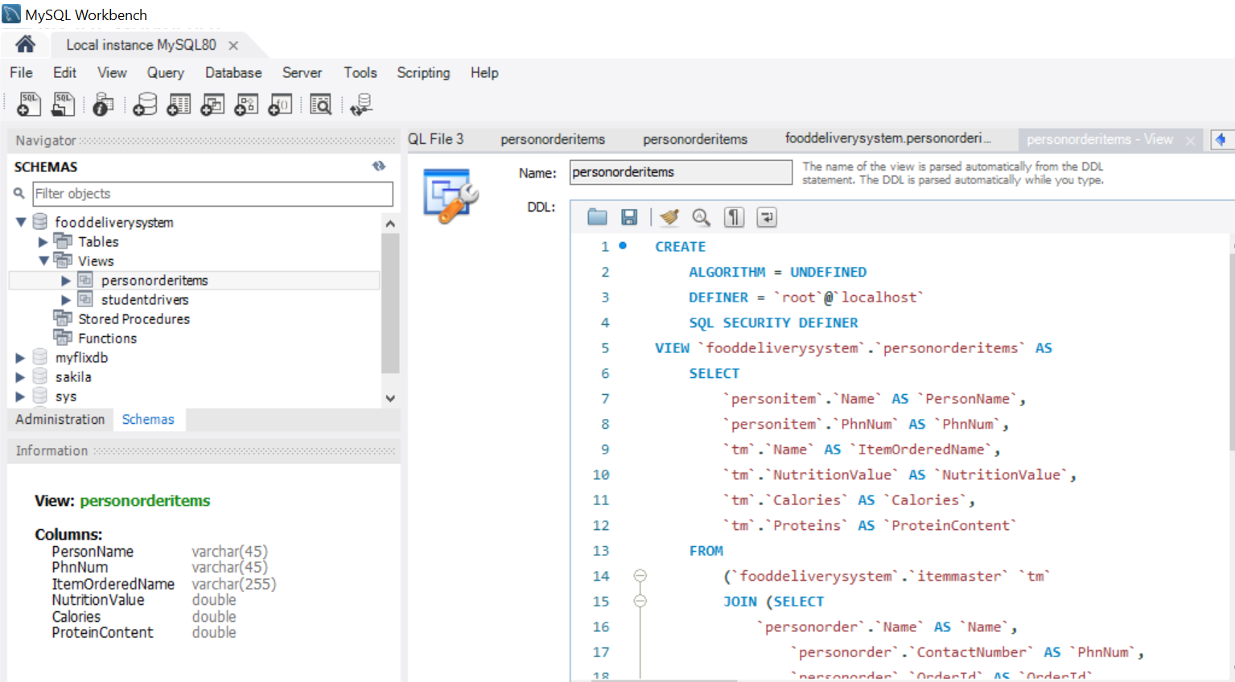

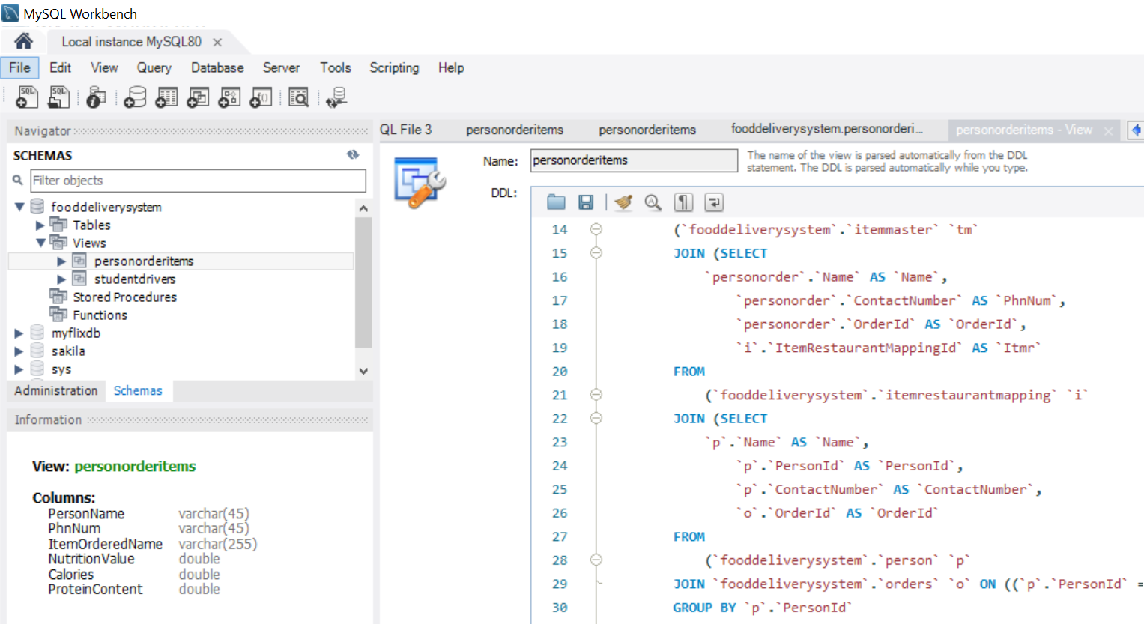

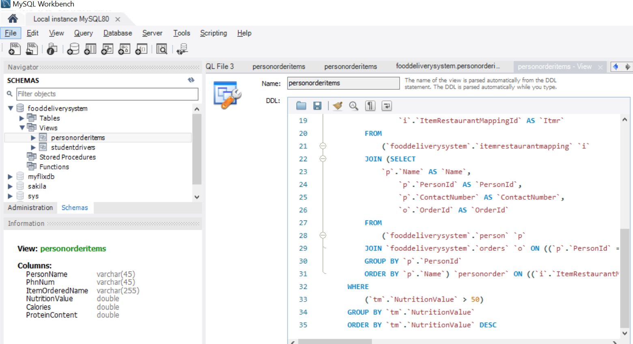

Output:

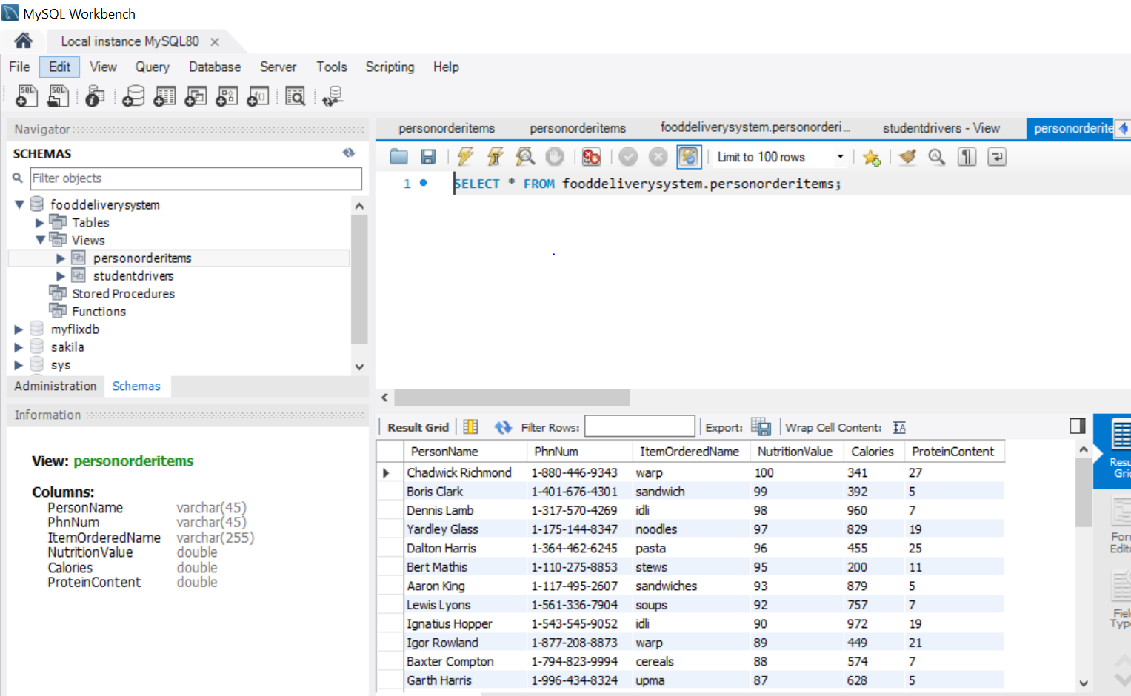

**ii)studentdrivers**

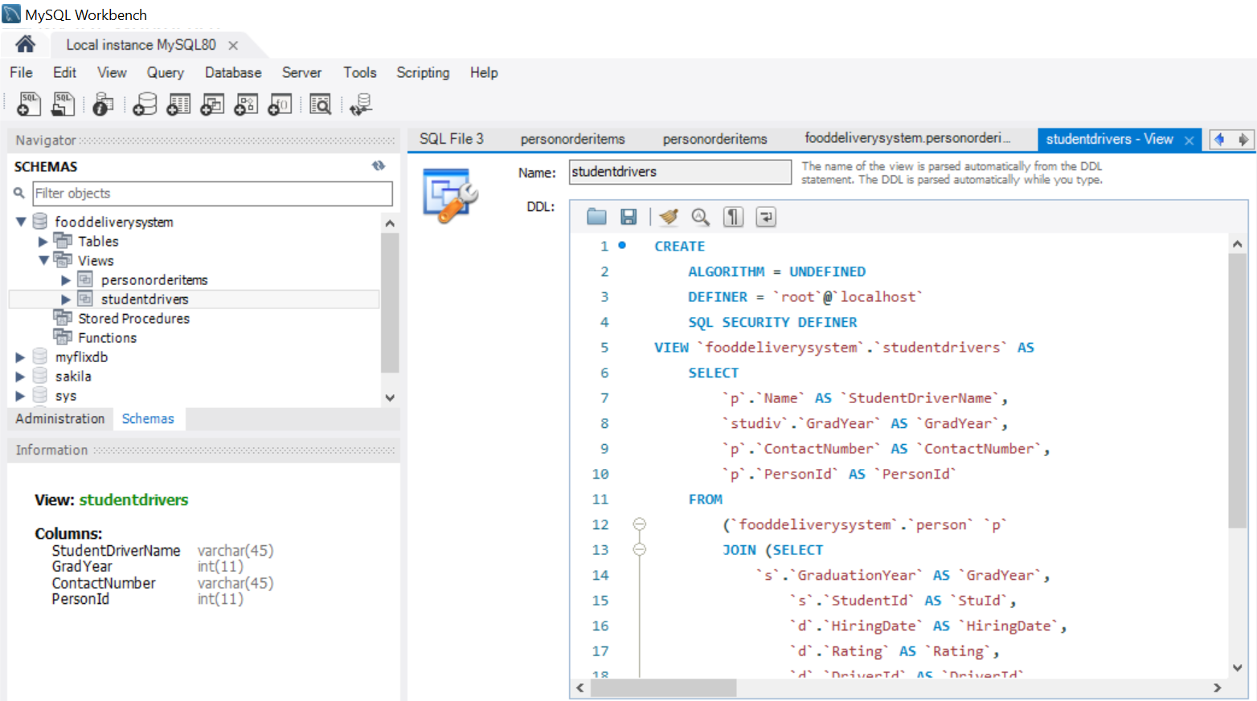

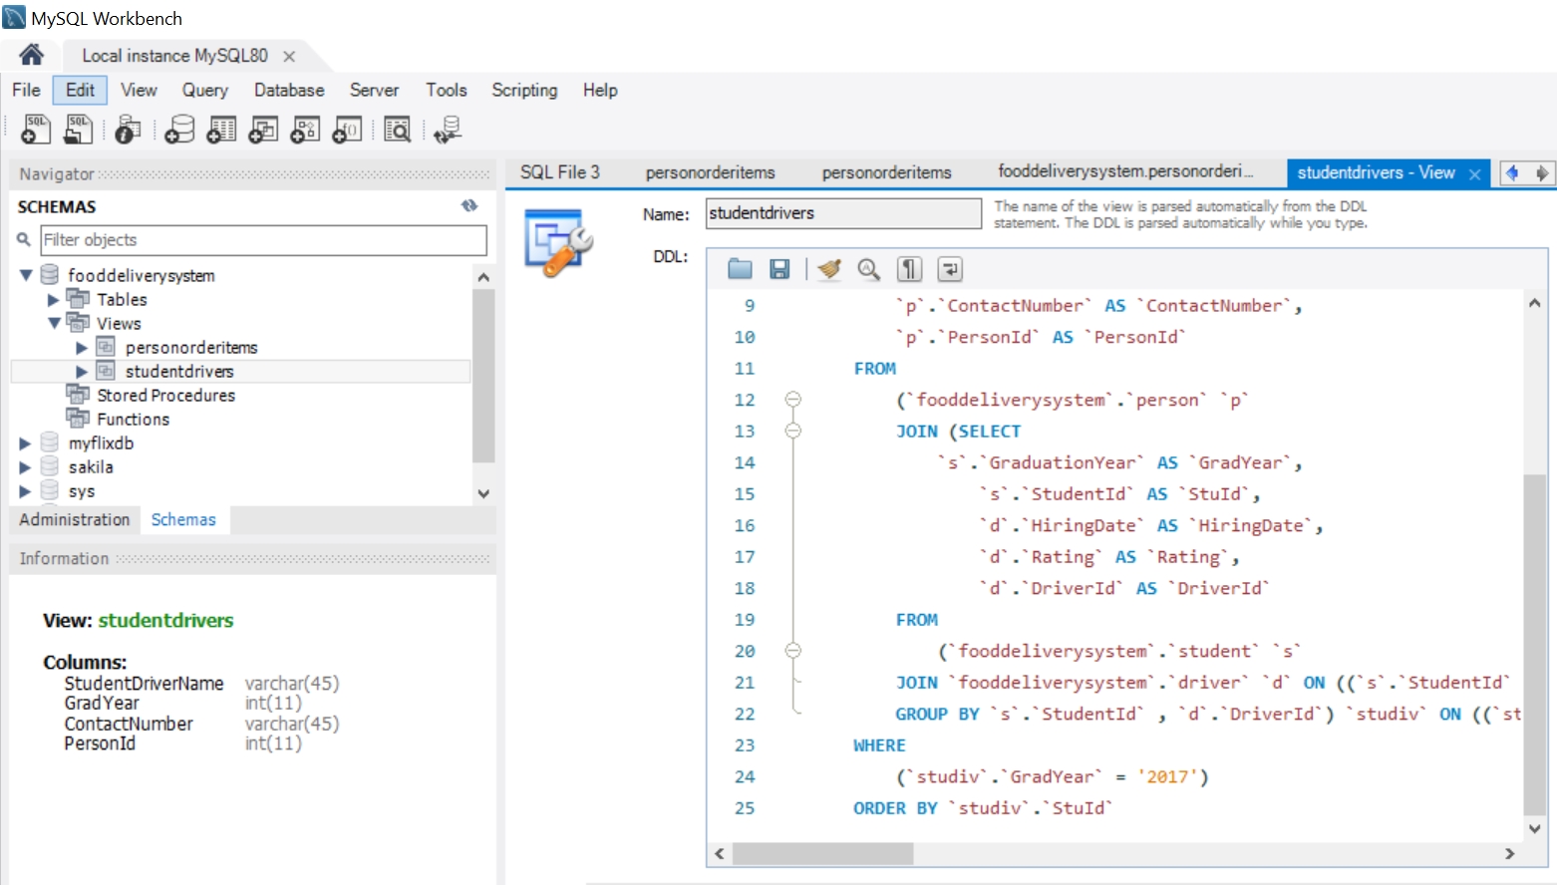

Output:

